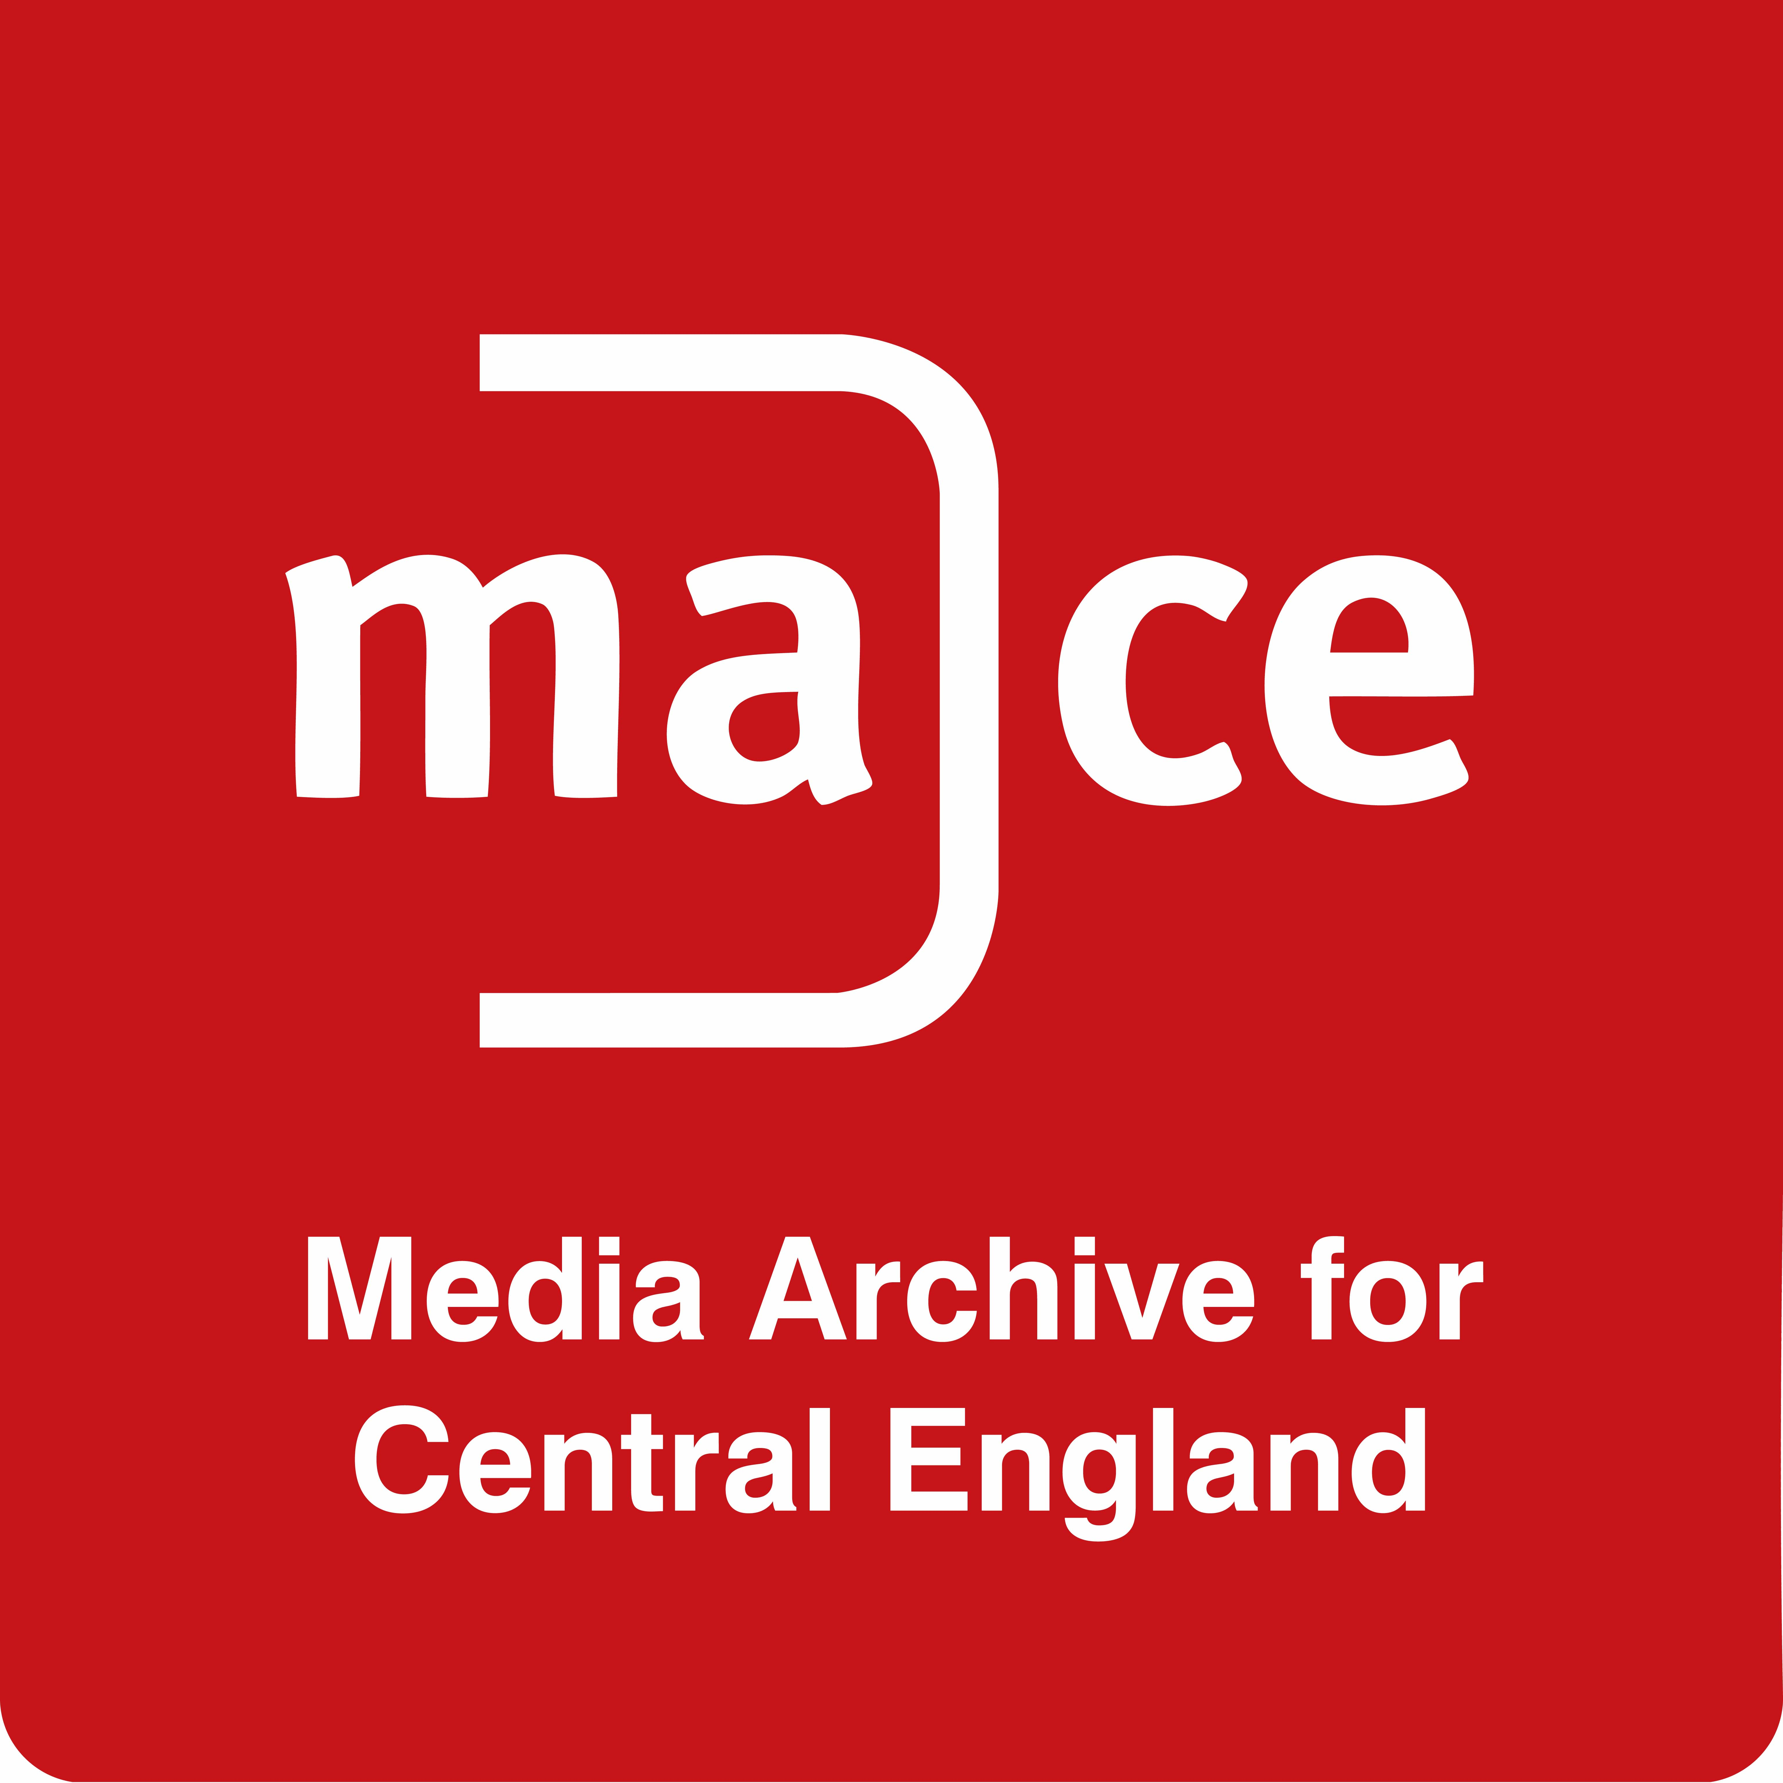
Donating to the Media Archive for Central England

MACE holds over 70,000 titles of amateur and professional material, both on film and tape that relate to the rich culture and history of the twelve counties of the Midlands in the UK. These moving images have the potential to open a unique window on the way we have lived our lives. For these reasons MACE is committed to preserving the moving image heritage of the Midlands for future generations to enjoy and study.

MACE is a small, dedicated team, with many years of archiving expertise. As a registered charity, we sustain ourselves raising income through public and lottery funding, sales, projects, exhibitions and donations. We are extremely grateful to our supporters.

Ways to donate:

- Bank transfer – Account number: 20287340 Sort code: 60-83-01
- By phone – Please call us on 01522 837750 and we would be happy to take your donation by debit or credit card
- By post – Please make cheques payable to Media Archive of Central England
- Donate by PayPal Giving via this link:
https://www.paypal.com/uk/webapps/mpp/search-cause?charityId=134043&s=3

Please let us know when you have made a donation, we would love to say thank you!

If you are a UK tax payer, please help us to claim an extra 25 pence for every £1 you donate by completing and returning the form below.

_ _ _ _ _ _ _ _ _ _ _ _ _ _ _ _ _ _ _ _ _ _ _ _ _ _ _ _ _ _ _ _ _ _ _ _ _ _ _ _ _ _ _ _ _ _ _ _ _ _ _ _

In order to Gift Aid your donation please “x” the box below, complete the amount and your personal details below.
☐ I want to Gift Aid my donation of £ to the Media Archive of Central England Ltd and any donations I make in the future
I am a UK taxpayer and understand that if I pay less Income Tax and/or Capital Gains Tax in the current tax year than the amount of Gift Aid claimed on all my donations it is my responsibility to pay any difference.

Full name:

Full home address:

Date:

